Lab 5: Satellite Orbit
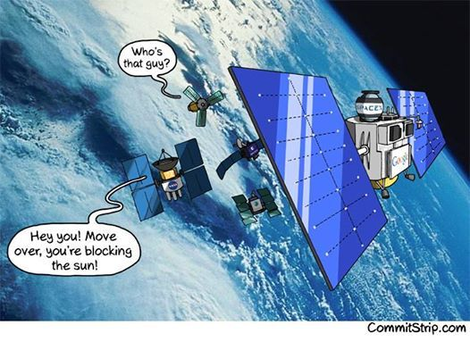
Overview:
This is the start of the end of our lab series. Throughout this series, you have gained a set of programming skills and now, I am going to give you a programming assignment that you need to accomplish all on your own. You will want to review our past labs, specifically kinematics and the fan cart simulator. In addition to that, you will also want to review the gravitational force equation:
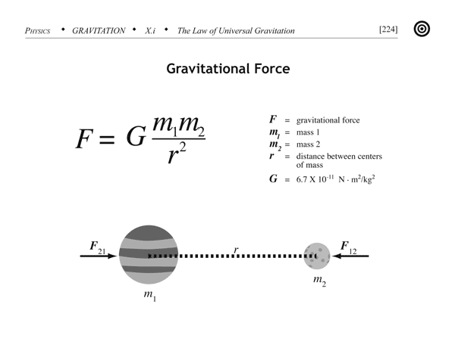

The objective of this lab will be straight forward, you will program a simulation of a satellite orbiting the earth. You will be responsible for coding everything from scratch, excluding the window size and libraries. I will help you much more with the next lab, so don't worry. The aim of this lab is to let you stand alone as a programmer. This task will also help you in the next lab, so make sure you spend ample time learning this lab. I will give you some guidance in this handout for the program, but I will refrain from providing large chunks of code.

Part 1:
The first part of the code always starts with the libraries that you want to import. In addition to giving you the libraries to import, I will also provide the scene size so your simulation will be clearly visible. Go ahead and copy and paste the code below into your own.

from __future__ import division
from visual import*
from visual.graph import*
import numpy

scene.y = 100
scene.width = 1000
scene.height = 1000

Part 2:
The next part of your code needs to contain your constants such as "big G", the earth's mass, the satellite's mass and delta t. Use these values in your code: G = 6.7e-11, mass of the earth = 6.7e24, mass of the satellite = 15e3, and delta t = 390.

Part 3:
Next, you want write the code for your objects. You will code four objects:
      - A sphere for the earth, centered at the origin with a radius of 6.4e6
      - A sphere for the satellite located at (0, -4.2e7, 0) with a radius of 1.0e6
      - A red trail that will follow the satellite.
      - A green arrow that symbolizes moment
Also, in this section, include a variable defined for the satellite's velocity, set to (4000, 0, 0) and a momentum variable that is defined by the momentum of the satellite. In addition to those two variables, define a time variable set to zero.

Part 4:
Finally, you are going to write a loop that will animate the objects. Start a loop where it will run as long as t < 1000000. While in the loop, set the rate to 125. In this loop you must update the position of the satellite, the arrow for momentum, and the trail. This should be very similar to how you updated the position of your free fall simulator and your fan cart simulator. Lastly, close the loop by updating the velocity, momentum, and time.

If your program runs correctly, you should see an arrow following an elliptical orbit around the earth. If you have achieved this, go ahead and save this program as Lab5Part4 and save it in your master file folder for submission during our in-class lab.

